Запросы и Вывод

Расписание Долженко

select l.date,l.class_number,l.group_id,teacher.last_name,teacher.first_name from lesson as l

join teacher on teacher.id = l.teacher_id

where teacher.last_name='Долженко' and teacher.first_name='Алексей'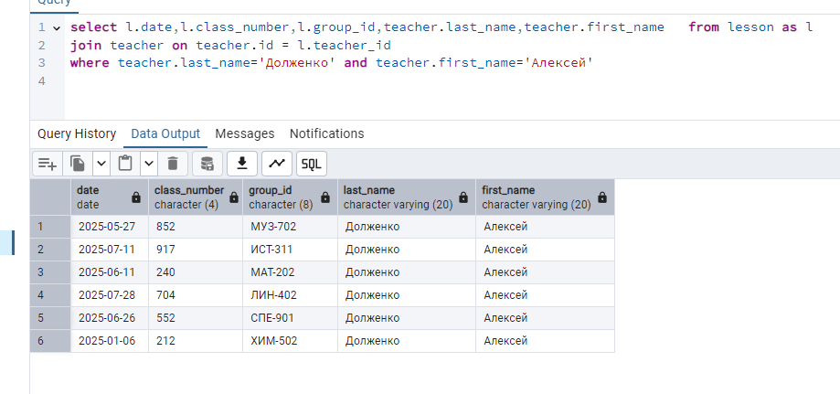

РасписаниеПРИ-311 на нечет понедельники

select * from lesson

where date_part('dow', date)=1 and group_id='ИСТ-311' AND date_part('week', date)::int % 2 = 0

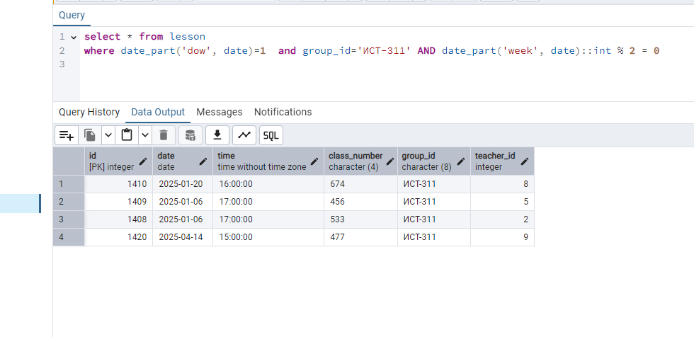

Расписание Аудитории 212 в среду

select * from lesson

where date_part('dow', date)=3 and class_number='212'

